Hindi Indic IME 1 Version 5.0
Contents

Introduction
System Requirements
Installation Notes
For Windows 2000
For Windows XP
Installation
Adding Input Locale
How to Use Indic IME
Keyboards

Introduction
Indic IME gives a very convenient way of entering text in Hindi using the English QWERT keyboard in any Office XP application, wordpad and notepad on Windows 2000/ Windows XP platform.
Top

System Requirement
Office XP on Windows 2000
Office XP on Windows XP
Top

Installation Notes for Windows 2000

IMEs cannot be installed or upgraded on a system that doesn't already support IMEs in the same language that you are installing. To enable Indic IME, go to control panel - > regional option and check Indic in "Setting for the system" and insert Win 2K CD in your CD-ROM drive.

Top

Installation Notes for Windows XP (Whistler)

IMEs cannot be installed or upgraded on a system that doesn't already support IMEs in the same language that you are installing. To enable Indic IME, go to control panel - > regional and Language. Select Language Tab, and check the option “Install files for complex scripts and left-to-right language and insert Win XP CD in your CD-ROM drive.

Top

Installation
- Run Hindi Setup.exe and follow the instructions in the setup program.
- Reboot your system.
Top

Adding Input Locale
1. Open Text Services in Control Panel.
- Select Keyboard under HI in Installed Services. Click Add.

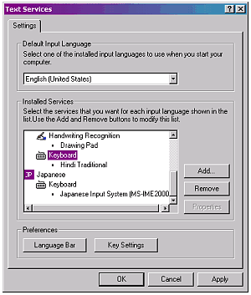

- Select Hindi in Input Language, check Keyboard Layout /IME box. And Select Indic IME 1.
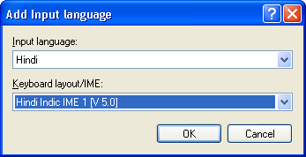

- Click OK.
Top

How to Use Indic IME:
- After installing Indic IME start any Office application, WordPad or Notepad.
- Click the Language Indicator located in the System Tray on the right side of the Windows taskbar, and click to select “Indic IME 1” from the shortcut menu that appears.
- Start typing in Hindi.

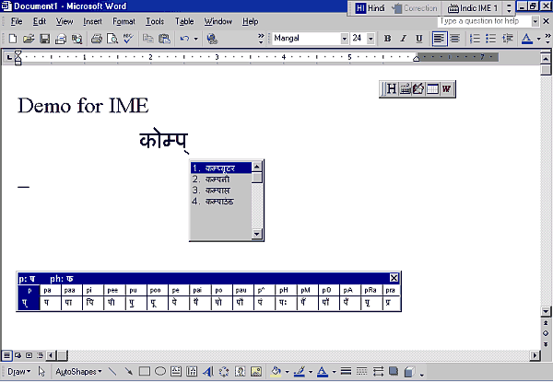
Hindi/English

Hindi Transliteration / Hindi Typewriter/
Hindi Inscript
AutoText On/Off

Help On/Off
AutoText

Customized
Wordlist
Top

Keyboards
Indic IME provides support for six types of keyboard:
- Hindi Transliteration – Using phonetic typing, the user can type his message in Roman using the Standard English keyboard, which is transliterated on-the-fly to Hindi. It works on the logic of phonetics and is most effective when you spell the word the way it is spoken.
- Hindi Remington- Hindi Remington is usual Remington Hindi typewriter Typing can be done as per the key mapping of the Remington keyboard.
- Hindi Typewriter- Another Hindi keyboard used in typing. Typing can be done as per the key mapping of Hindi typewriter keyboard.
- Inscript Keyboard- Another Hindi Keyboard where the user types the basic characters in sequence and an underlying logic determines that which of these characters have to be combined and substituted to form a glyph.
- Webdunia Keyboard- Another Hindi keyboard used in typing. Typing can be done as per the key mapping of Webdunia Keyboard.
- Anglo Nagari Keyboard- Another Hindi keyboard used in typing. Typing can be done as per the key mapping of Webdunia Keyboard.
Top

